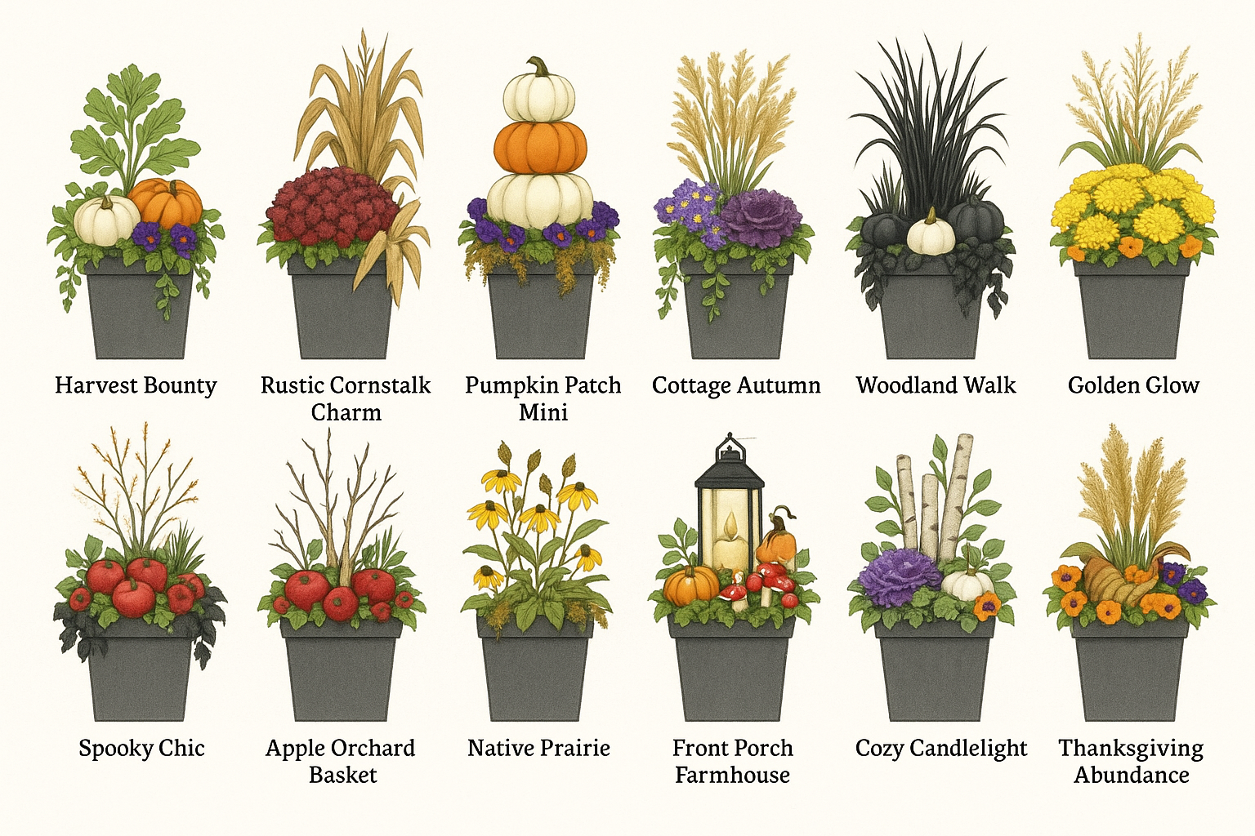
1. Harvest Bounty
- Ornamental kale or cabbage as the centerpiece
- Flanking mini pumpkins or gourds
- Trailing ivy or creeping Jenny for spill

2. Spooky Chic
- Black ornamental grass or purple fountain grass
- White mini pumpkins and black-painted gourds
- Trailing dark sweet potato vine

3. Thanksgiving Abundance
- Ornamental kale, mums, and violas mixed in tiers
- Cornucopia-style spilling gourds at the base
- Feathery millet or wheat stalks rising in back

Here are some other photos for inspiration:
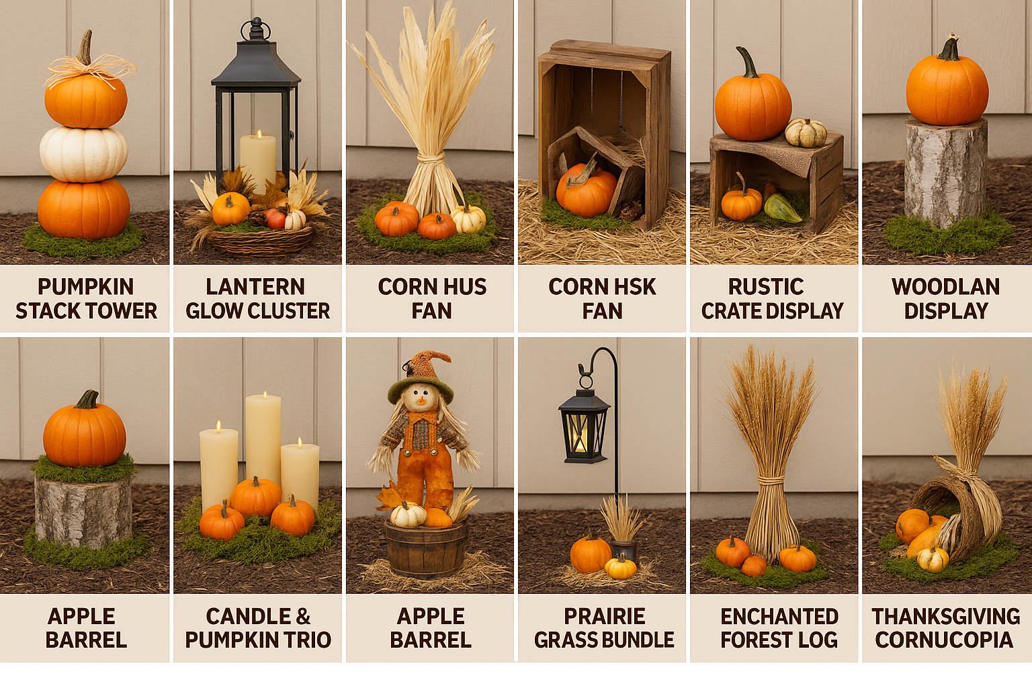
See next page for more inspiration…
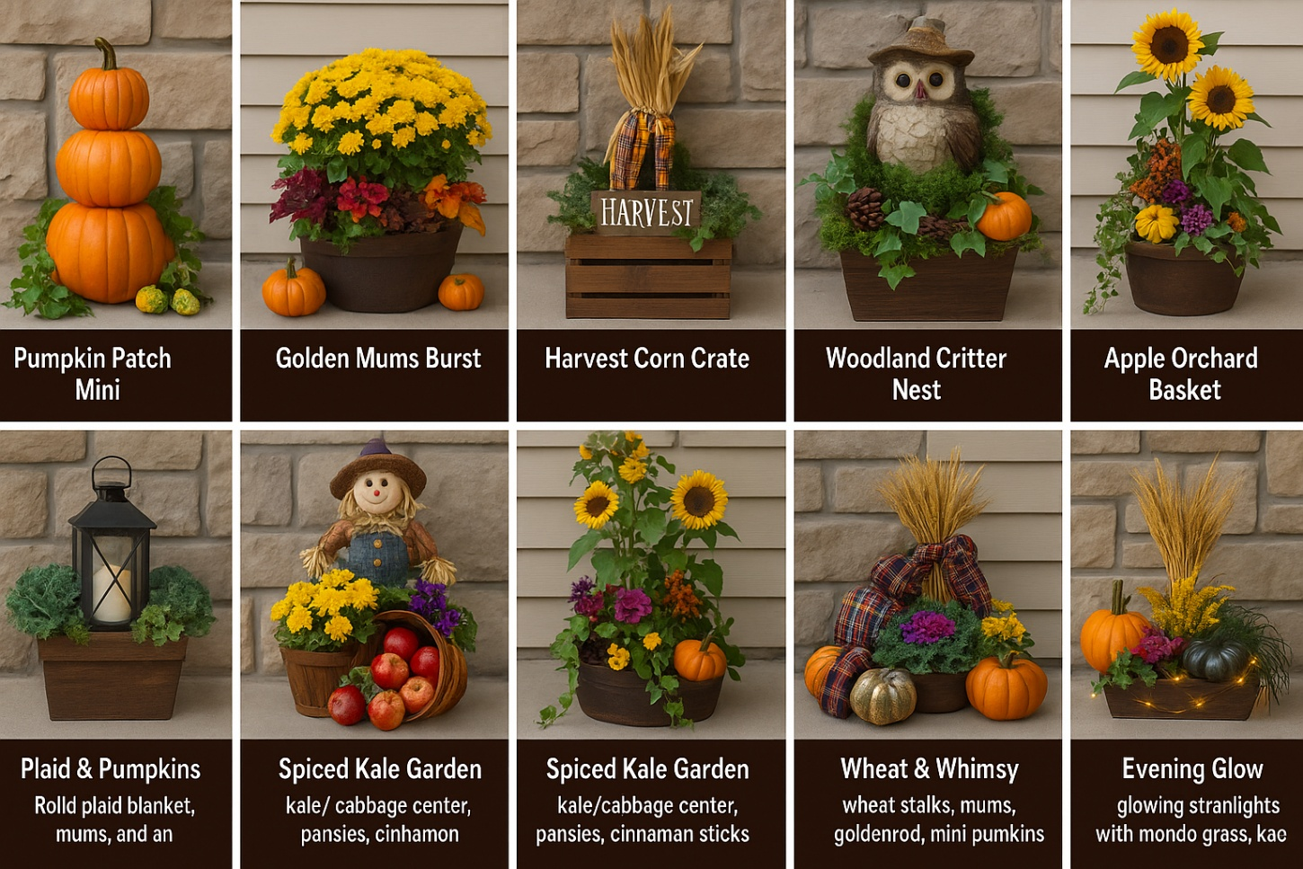

Happy Decorating!

